CENTRALIZED & CLIENT- SERVER ARCHITECTURE FOR THE DATABASE

Centralized
In Centralized Architecture, the mainframe computers are used for processing all system functions including User application Programs and User Interface Programs as well as DBMS functionalities. This is because in earlier days, most users accessed such systems via Computer Terminals, which can’t Process and they have only display capability. Therefore, the Processing used to take place in these Computer Systems and the display information is sent to display terminals and these terminals are connected to mainframe computers via various kinds of Networks.
As the days pass by, we are now having Personal Computers (PC’s) in the market. But still in the beginning Centralized Architecture for DBMS was used. Gradually the DBMS systems started to make use of Processing Power in the used side i.e Computers have come with Processing Power and in turn led to the use of Client/Server Architecture.
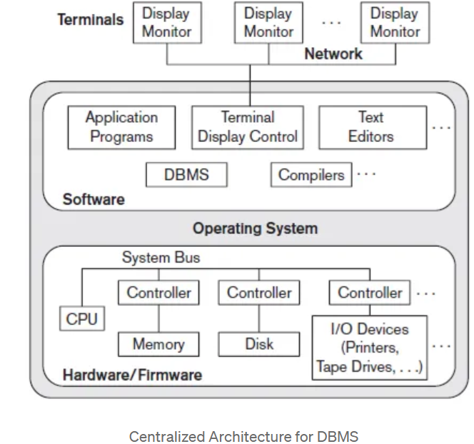

Client/Server Architecture:
The concept of client/server architecture assumes an underlying framework that consists of many PCs as well as a smaller number of mainframe machines, connected via LANs and other types of computer networks. A client in
this framework is typically a user machine that provides user interface capabilities and local processing. When a client requires access to additional functionality, such as database access which does not exist at that machine, it connects to a server that provides the needed functionality.
A Server is a system which contains both Hardware and Software which provides services to client Machines like file access, printing and database access.
1)Two Tier Client/Server Architecture for DBMS:
Two-tier means that our Architecture has two layers, which are client layer and Data layer. In Client layer we have several Client machines which can have the access to the database server. The API present on the client machine will establish the connection between the machine and the Database server through JDBC something else. This is because Clients and Database Server may be at different locations. Once this connection gets established, the Interface present on the client machine contains an Application Program on the back-side which contains a query. This query will be processed by the Database server and in turn the queried information will be sent to the client machine.
For example, if we query the database to retrieve some information, the query will be Processed by Database server and that information will be sent to the client by Database server itself!!!

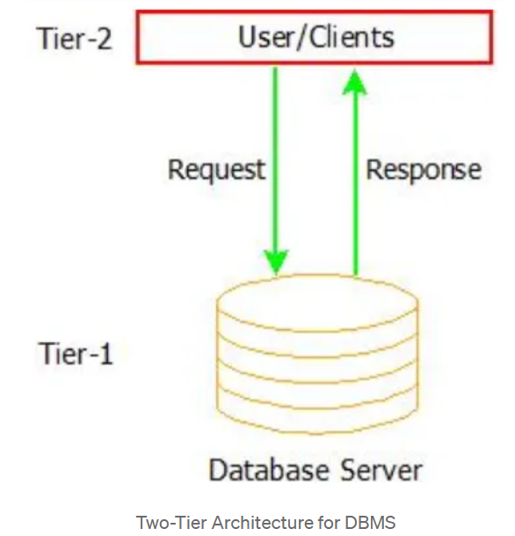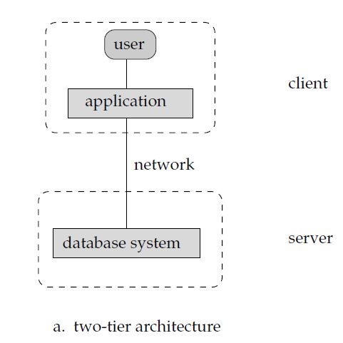

2) Three-Tier client/server Architecture for DBMS:
There is an additional layer which acts as an intermediate between Client layer and Data layer called Business logic layer. Business logic layer is the layer where the Application Programs are processed. Here the Application Programs are processed in the Application server itself, which makes it different from Two-tier Architecture where queries are processed in the database server.
Simply the Client machines will contact Application Server which in turn processes our Application Programs and fetches the Required Data from Database and then sends this Information back to the client machine in the suitable format only.
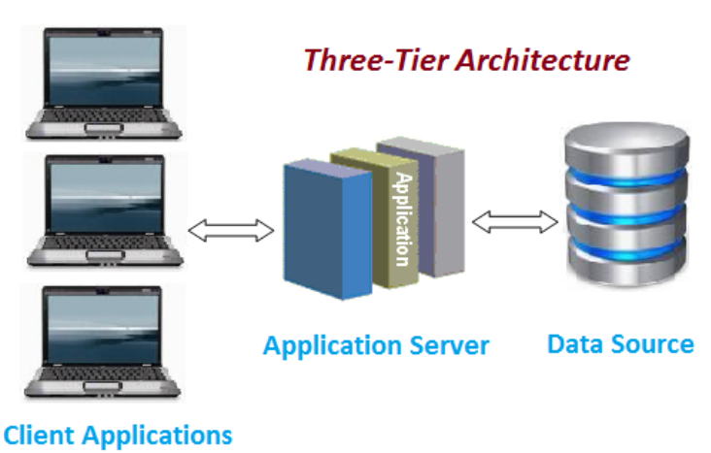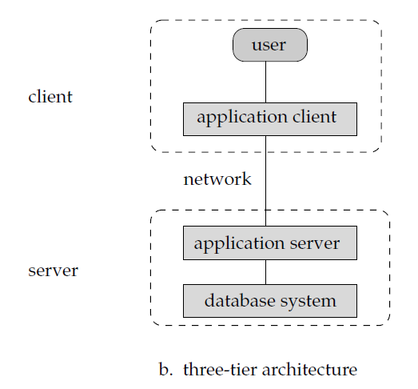
Three-Tier client/server Architecture for DBMS
Now we may think that Two-Tier Architecture is easy to use and maintain and why we should go for Three-Tier. The Reason is Three-Tier Architecture is Scalable and more secured.

Even it is easy to maintain Two-Tier Architecture of DBMS it is still not scalable when we have large number of clients and also not secure because the clients are having direct access to database server. But Three-Tier Architecture ensures Scalability and Security of the data because of the presence of this Intermediate layer which processes the queries and it just retrieves data from server instead of processing in the server to take place.

